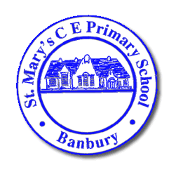  Headteacher: Mrs Victoria Woods  17th May 2024 | St Mary’s C E Primary School  Southam Road  BANBURY  Oxfordshire  OX16 2EG  Telephone: 01295 263026  Email:office@banburystmarysschool.co.uk  Web: www.banburystmarysschool.co.uk
Dear Families,

As you know, we had a visit from the SIAMS Inspector ( the Inspector who looks at school because we are a Church School) last week. He spent the day with us, met all the staff, lots of children and group of parents. A huge thank you to that group, it was lovely to have you in school.

I am pleased to say we can now share the outcome of the Inspection with you. Unlike OFSTED, this does not have a one word grading, they tell us if we are 'Living up to our Foundation as a Church school'. The very firm outcome is YES WE ARE!! In fact the inspector did say to me, "It's BRILLIANT!" He said lots of other things too and really showed an empathy and understanding of our school, community and the work we do.

We are very pleased, and proud, of this report and we hope you are too. The firm understanding is that each and everyone of your children, you as families and our staff team are loved and cared for with equality and compassion and that we offer our children a wonderful place to learn.

Attached is a copy of the report and it can also be found on the school website. We hop you enjoy reading it, please do ask if you have any questions,

Sincerely

Victoria and the entire team at St Mary's.

